**FUNCTIONS:**

**Q:1**

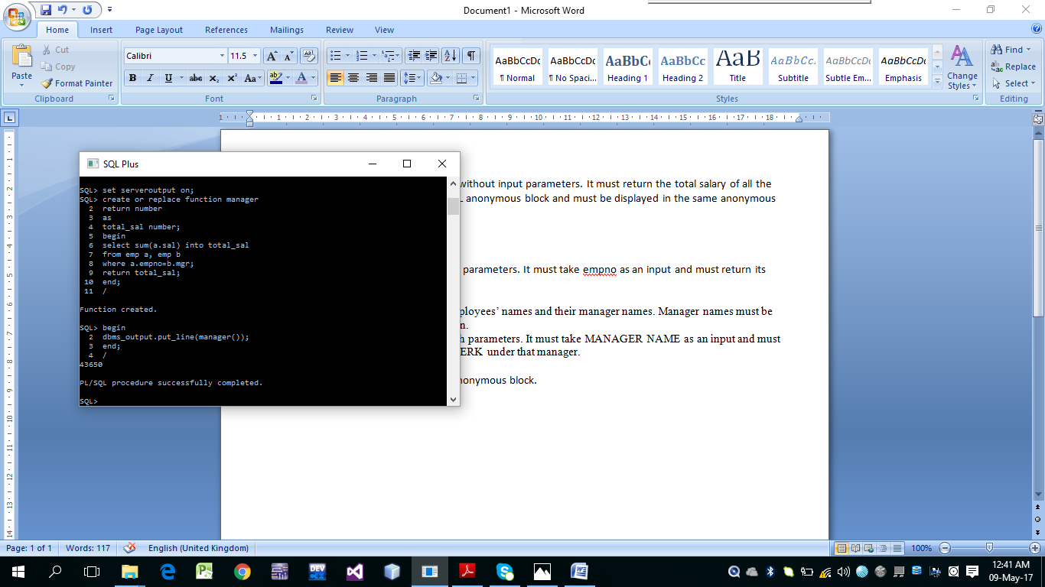

Q: 2

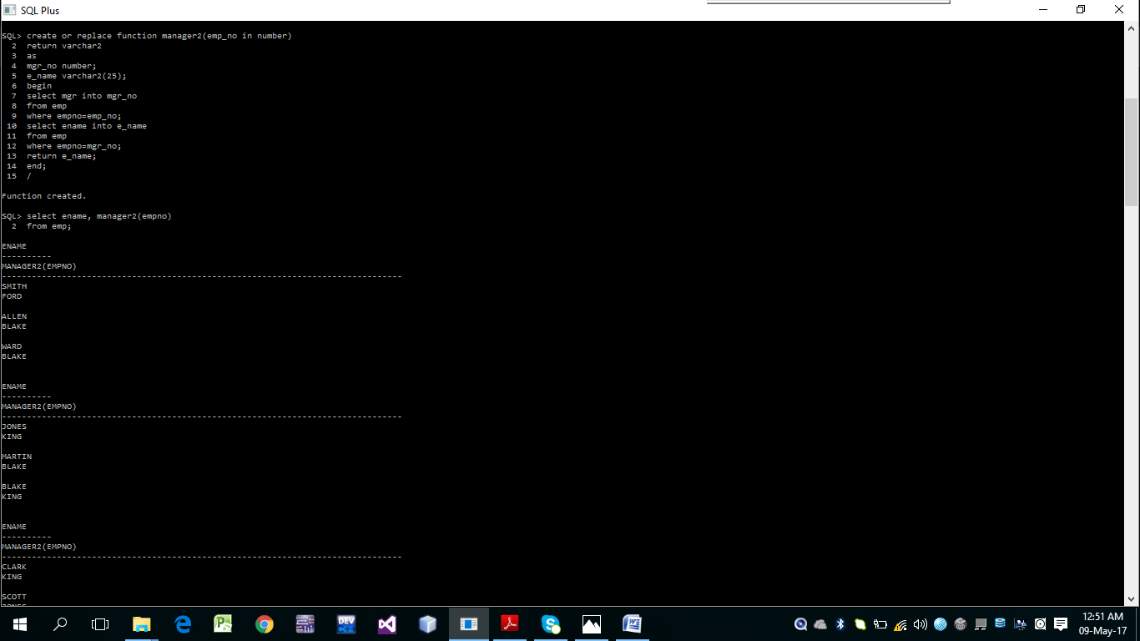

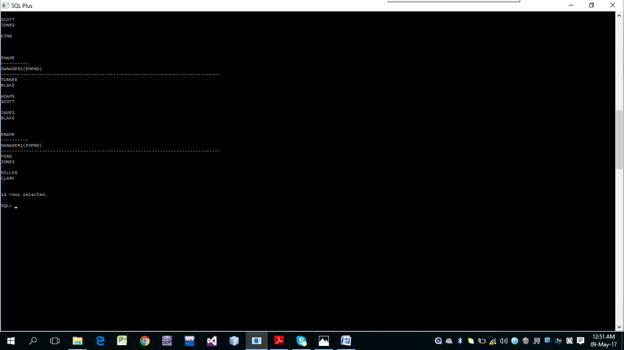

Write a SELECT statement to display all employees’ names and their manager names. Manager names must be displayed using MANAGER2 stored function.

3. Create a stored function MANAGER3 with parameters. It must take MANAGER NAME as an input and must display all employees’ names working as CLERK under that manager.

MANAGER3 must be called from a PL/SQL anonymous block.

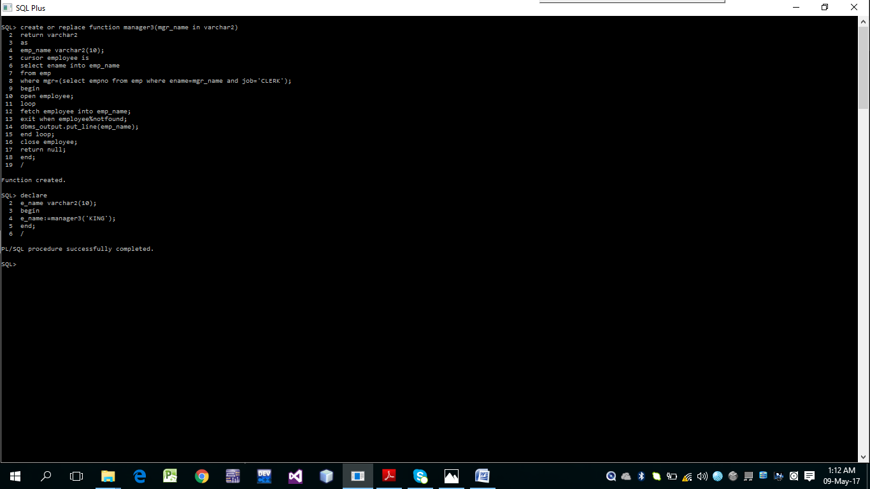

**TRIGGERS:**

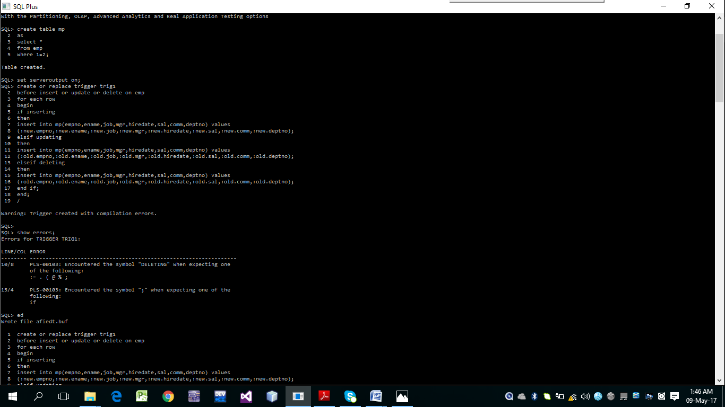

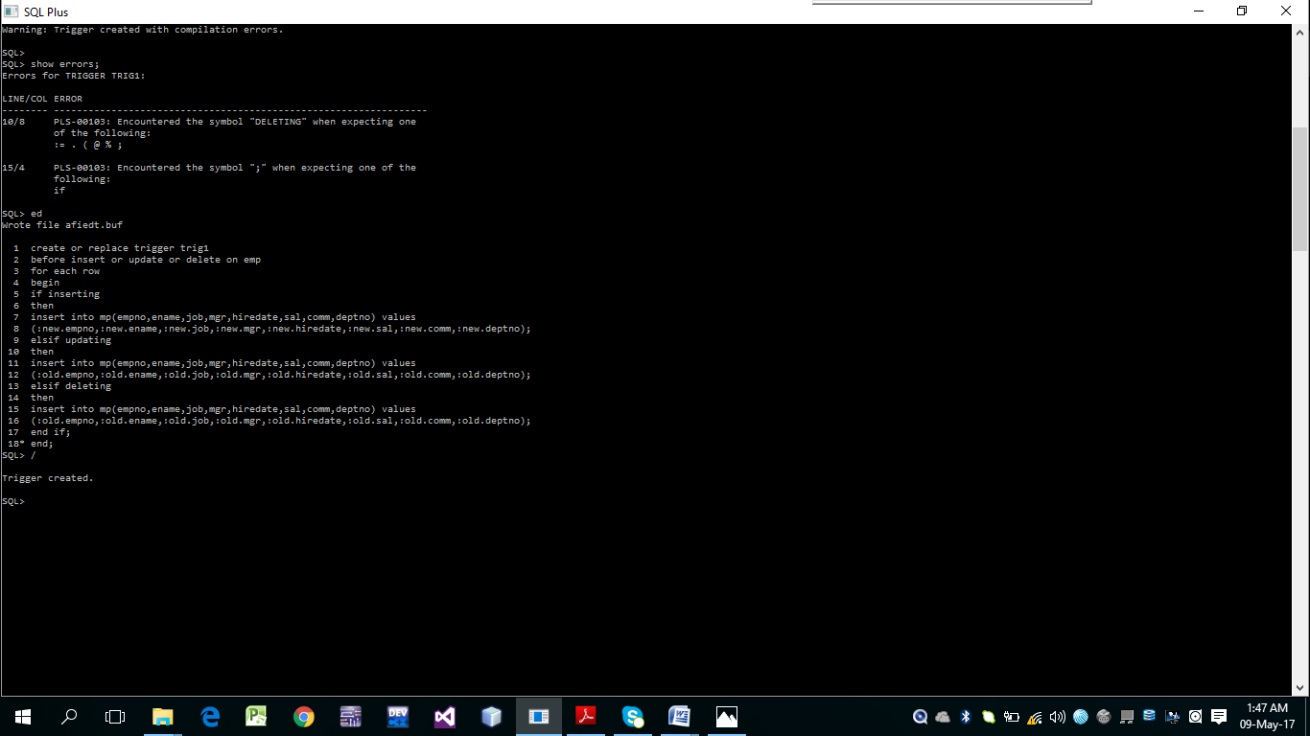

2. Create a trigger on EMP table which stops any person from INSERT or UPDATE of the record if the new job of the affected record is CLERK and new salary is less than 5000.

